### Component “AZERTY”

#### Overview

This new component, packaged as a XXX (MoDisco discoverer or Sparx EA extension), is based on YYY. It allows producing ZZZ

#### Functional description

This component currently considers:

* As input: XXX
* As output: YYY

The intermediate Java code model being a direct representation of the content of the initial Java sources, the actual conceptual mapping between Java and UML (Class Diagram) is specified by the Java-to-UML model transformation as previously introduced. An overview (non-exhaustive) of this mapping between elements from these two metamodels is presented in Table 1.

Table 1 Mapping (excerpt) used in the XXX-to-YYY discovery/transformation

|  |  |
| --- | --- |
| **XXX metamodel** | **YYY metamodel** |
| Element A | Element B |
| Package | Package |
| [ClassDeclaration OR NamedElement] **(1)** | Class |

1. ***:*** *Note that...*

#### Technical specifications

The XXX-to-YYY model transformation has been developed and is being executed thanks to the ATL tooling **Erreur ! Source du renvoi introuvable.**. The implemented ATL artefacts are the following ones*:*

* An ATL module where all the transformation rules between the XXX elements and the YYY ones are defined.
* An ATL library containing all the helpers (i.e., reusable methods in the ATL jargon) used by the different rules in the ATL module.

This transformation has been embedded in and packaged as a MoDisco Discoverer (currently named *fr.inria.artist.modisco.java.uml.discoverer.java2uml*). This discoverer allows...

As a summary, here are the concrete technologies that have been used and deployed in the context of this component:

* XXX metamodel and XXX model discovery [ref]
* YYY metamodel [ref]
* (XXX-to-YYY) model transformation [ref]

General information:

* Status: Beta
* Release: 0.2

#### Download and installation instructions

Thus, this component requires the following software to be installed:

* Eclipse Platform (get the latest Eclipse Modeling bundle)
* Eclipse MoDisco SDK
* Eclipse ATL SDK
* Eclipse UML2

As for the other newly developed components, the sources can be downloaded from the public repository (cf. section **Erreur ! Source du renvoi introuvable.**).

#### User manual

To use the component, you can start from a XXX model, as previously obtained from ZZZ for instance, and then:

* Right-click on...
* Select the following menus...
* Enter, as shown on Figure 1, whether you want to...
* Validate your choices in the window, and run the discovery process. The resulting YYY model will by default (i.e., if not specified differently) be...

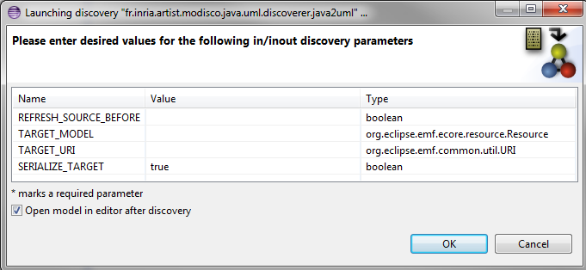

Figure 1 Parameter selection for the UML Class Diagram Model Discoverer

The obtained YYY model can finally be navigated using the MoDisco Model Browser for instance.

#### Licensing information

This component is provided as open source under the Eclipse Public License [ref].